**Instagram User Analytics**

**A) Marketing Analysis:**

**Loyal User Reward:** The marketing team wants to reward the most loyal users, i.e., those who have been using the platform for the longest time.

**Your Task:** Identify the five oldest users on Instagram from the provided database.

**SQL QUERIES**

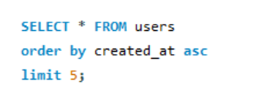

**SQL OUTPUT**

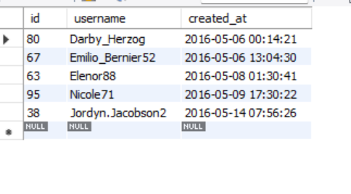

**Inactive User Engagement:** The team wants to encourage inactive users to start posting by sending them promotional emails.

**Your Task:** Identify users who have never posted a single photo on Instagram.

**SQL QUERIES**

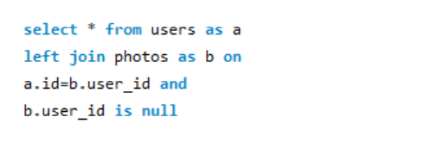

**SQL OUPUT**

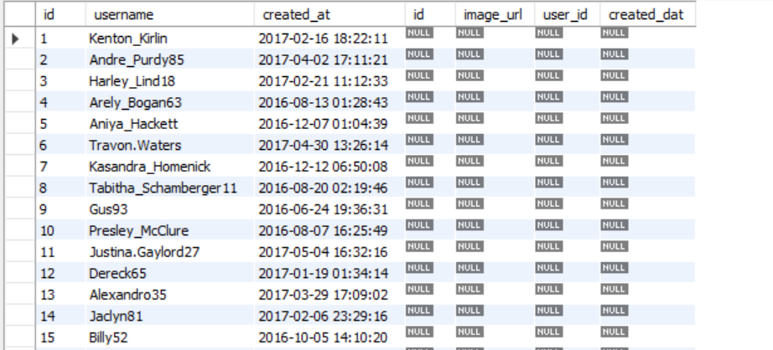

**Contest Winner Declaration:** The team has organized a contest where the user with the most likes on a single photo wins.

**Your Task:** Determine the winner of the contest and provide their details to the team.

**SQL QUERIES**

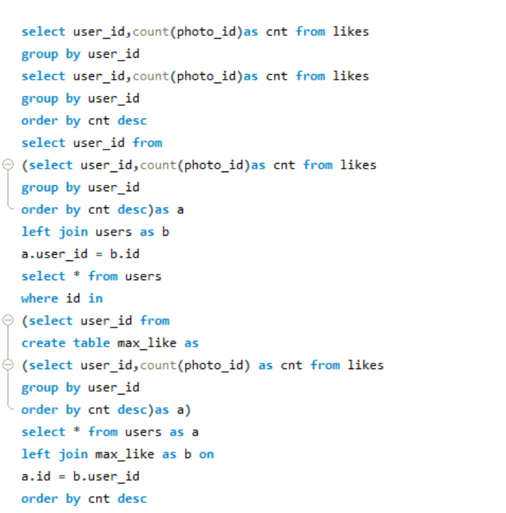

**SQL OUTPUT**

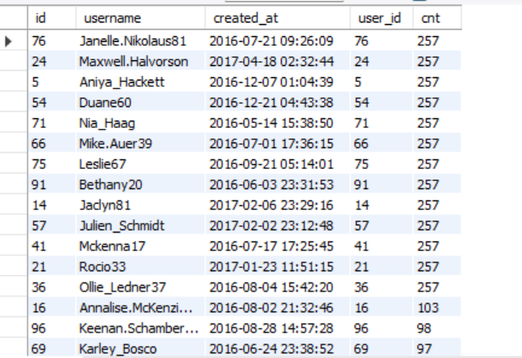

**Hashtag Research:** A partner brand wants to know the most popular hashtags to use in their posts to reach the most people.

**Your Task:** Identify and suggest the top five most commonly used hashtags on the platform.

**SQL QUERIES**

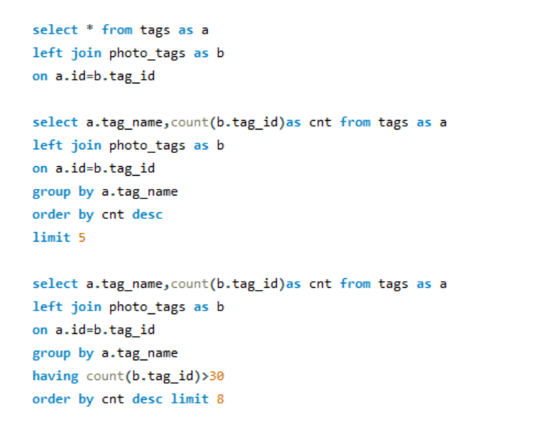

**SQL OUTPUT**

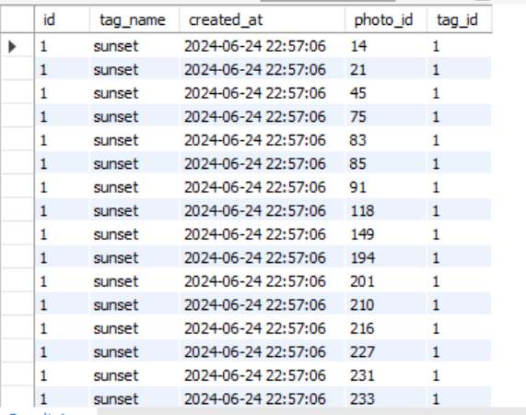

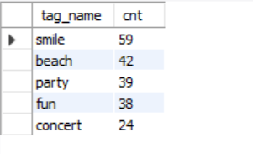

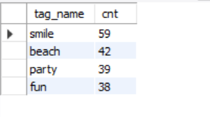

**Ad Campaign Launch:** The team wants to know the best day of the week to launch ads.

**Your Task:** Determine the day of the week when most users register on Instagram. Provide insights on when to schedule an ad campaign.

**SQL QUERIES**

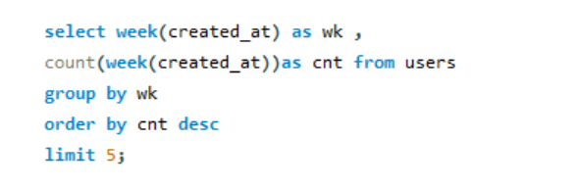

**SQL OUTPUT**

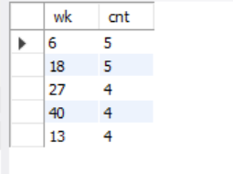

**B) Investor Metrics:**

**User Engagement:** Investors want to know if users are still active and posting on Instagram or if they are making fewer posts.

**Your Task:** Calculate the average number of posts per user on Instagram. Also,provide the total number of photos on Instagram divided by the total number of users.

**SQL QUERIES**

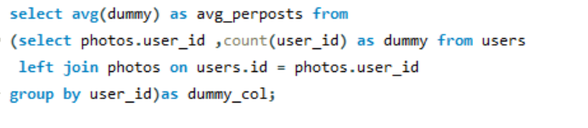

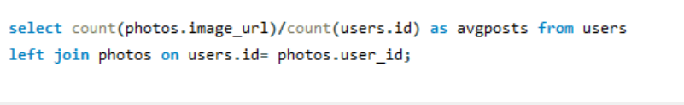

**SQL OUTPUT**

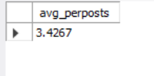

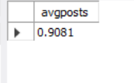

**Bots & Fake Accounts:** Investors want to know if the platform is crowded with fake and dummy accounts.

**Your Task:** Identify users (potential bots) who have liked every single photo on the site, as this is not typically possible for a normal user.

**SQL QUERIES**

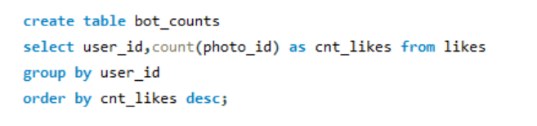

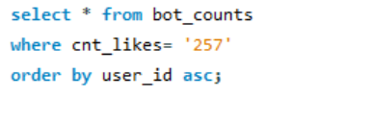

**SQL OUTPUT**

